19.1.1 Editors - Drivers Editor - Header tools and options
Introduction 1
Header Tabs 1
Use Normalization, Create Ghost Curves 2
Use Normalization 2
Auto Normalization 2
Create Ghost Curves 2
Show Hide elements 2
Only Show Selected 2
Show Hidden 2
Only Show Errors 2
Filters 2
Filter by Collection 2
Filter by Type 3
Options 3
Sort Data Blocks 3
Auto Snap 3
Proportional Editing 3
Pivot Point 3
Bounding Box Center 3
2D Cursor 3
Individual Centers 4
Easing Mode 4
Easing Mode 4
Last Operator Set Keyframe Easing Type 4
Type 4
Keyframe Handle Type 4
Last Operator Set Keyframe Handle Type 4
Type 4
Keyframe Interpolation 5
Last Operator Set Keyframe Interpolation 5
Type 5

Introduction

The header contains various menus and tools. This chapter here is about the tools, modes and options elements in the header.

The text menus are covered in a own chapter each. They vary too much, dependent of mode and object type.

Header Tabs

The tabs at the very left allows you to switch between the four most important editor types by one click. Dope sheet Editor, Graph Editor, Driver Editor, NLA Editor.

Use Normalization, Create Ghost Curves

Use Normalization
Normalizes the curves so that the maximum does not exceed 1 and the minimum does not go lower than -1

Auto Normalization
Automatically recalculate curve normalization when you modify the curve.

Create Ghost Curves
Creates a snapshot of the current curves, and displays it as a background image in the viewport. This background image is not permanent, and will be deleted when you close Bforartists.
When a ghost background image is created then the button turns into a delete button with which you can remove the ghost image.

Show Hide elements

Only Show Selected
Display only the data for the selected object in the list of elements. If off it displays all available animation data of the whole scene.

Show Hidden
Include channels from objects / bones that are not visible. This feature just works with Only Selected off.

Only Show Errors
Only display F-Curves and Drivers that have errors or are disabled.

Filters
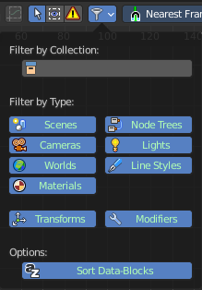
The show hide elements allows you to filter out the general elements. The Filters panel allows you to filter out further elements.

Filter by Collection
Just display the content from the chosen collection in the list of elements.

Filter by Type
In this section you can choose what type of animation data should be displayed. The names should be self explaining.

Options

Sort Data Blocks
Alphabetically sort the data in the list of elements.

Auto Snap

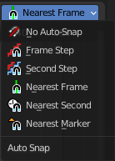
Adjust how the selected keyframe or fcurve point snaps to other elements.

Proportional Editing

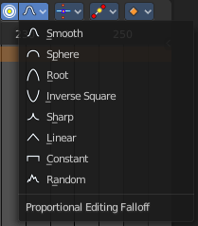
Enable proportional editing.

Proportional editing allows you for example to scale two keyframes and influence the not selected neighbor keyframes in a proportional way. Or the proportional editing of fcurve points.

The drop down menu to choose the proportional editing falloff method is just available when the proportional tool is active.

Pivot Point
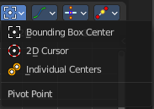
The pivot point defines the center of manipulations.

Bounding Box Center
Transformation happens around the bounding box center.

2D Cursor
Transformation happens around the timeline cursor.

Individual Centers
Transformation happens around the individual centers of the selected elements.

Easing Mode

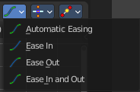
Easing Mode
The easing methods in the interpolation mode menu are for the easing shape. This menu allows you to choose an easing method.

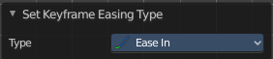
Last Operator Set Keyframe Easing Type

Type
Set the easing type.

Keyframe Handle Type
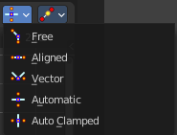
Set the handle type for the currently selected keyframes.
This is a feature for the Graph editor, where each curve point has its own handler with which you can influence the curve behavior. But the handler type also influences how the animation curve acts at the chosen keyframes. So it has its use in the dope sheet editor too.
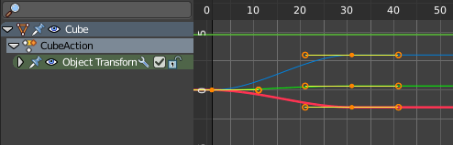

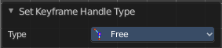
Last Operator Set Keyframe Handle Type

Type
Set the handle type for the currently selected curve point.

Keyframe Interpolation
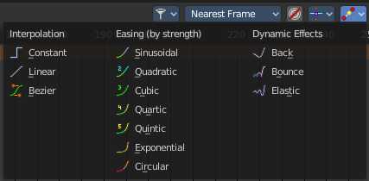
The keyframe interpolation mode defines how the curve acts from keyframe to keyframe. You can have a linear curve between two keyframes instead of a bent one for example.
The easing methods here in the interpolation mode menu are for the easing shape. There is also an easing menu where you can choose a easing method.

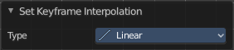
Last Operator Set Keyframe Interpolation

Type
Set the interpolation mode.

